METABOLE – Reset your fat point and lose weight fast!
Loose between 7kg to 12 kg within 3 – 9 weeks!
This is your opportunity for effective weight loss in a relatively short space in time, with the added benefit of keeping the weight off if you listen to your body. Our clinical trials indicate between 7 kg to 12 kg within 3 to 9 weeks on our DIY hCG health and weight-loss program done in conjunction with Metabole clinic.
WHAT PEOPLE SAY
“Thank you so much for the hCG, its been a life changer! Before hCG, always tired and sluggish and on anti depressants. After 6 weeks I have lost 10kg, feeling lively, healthy and happy body, mind and soul. No longer on anti depressants! It has been a journey so worth while and I recommend this diet to everyone I encounter.” Carla
“I was slightly hungry while doing the program, but never felt or looked better in such a short time. A lot of my food allergies have disappeared so I am thrilled with the results” Liezel
“What a joy to be fitting into my old clothes that I haven’t been able to wear in a while. Thank you so much for the awesome journey we have been on. My husband is down 9kg in three weeks and is looking and feeling great, and my girl is back to her radiant self. Thank you!” Barbara
“Ek het regtig gesond geeet en baie oefening gedoen maar my gewig het n probleem gebly. Na die ouderdom van 40 jaar het dit net moeiliker geraak. Ek het stelselmatig jaar na jaar net swaarder geword met meer vet om my middel. Dit het my so gepla dat ek gewonder het waar ek sou opeindig by 50. Ek koop al lank by julle al my aanvullings en toe ek 3 weke gelede jou vra of daar iets is wat my kan help was ek so opgewonde toe ek van die dieet hoor en hoeveel mense dit al gedoen het. Ek het al die inligting verslind en als het net sin gemaak en ek kon dit verstaan. Ek het my man vertel en hy het gese hy sal dit saam met my doen. Ek is nie n dag spyt nie. Dit was tough but anything you sets your mind too you can do. Ek het 6kg verloor en wat so amaizing is dit is alles vet. Ek voel fantasties in my klere en al ons sinus probleme is ook weg. Ek het baie erg nagswete gekry dit is ook weg. Ek het die eerste 3dae 800g opgetel maar het dit verloor weer met die stabiliserings dieet. Ek hou by dieselfde kossoorte net met my gesonde olies by en klein bietjie vet by vleis as ek so voel. My man se ronde maag is so te se weg. Hy het amper 8kg verloor. Vir almal wat twyfel komaan vat n kans. Jy kan niks verloor nie net wen hierby. Dink net ons kan weer kans sien vir n swembroek sonder om selfbewus te voel. Meer as enige iets anders leer die dieet jou om die regte kossoorte te eet” Jolanda vN.
————————————————————————————————————————–
ABOUT THE PROGRAM
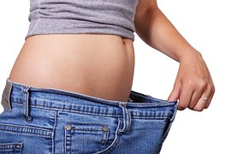
Dr Charl did thorough research, studying all the scientific research of Dr A T W Simeons and Leslie Kenton’s book “New Curo Romano Weightloss Plan” to make sure that this programme is completely safe, as for us this is extremely important.
“It is first about your health and then about your fat loss.”
The most exciting part of this whole journey is learning to understand your body. You’ll be learning more about how to play by your own body’s rules – by testing important foods and paying attention to what it tells you and how it reacts to the new foods you trust. It’s all about becoming conscious of your body’s likes and dislikes.

THE COST
DIY:
Home kit at a cost of R2200.00 excluding courier fee.
————————————————————————————————————————–
This is what Dr Charl’s research revealed……….
FAT-BANKING CONTROLLING
Dr Simeons was able to pinpoint that the body’s fat-control and fat-bank regulating system is located in an area of the brain known as the diencephalon and not so much the thyroid as most presumed.
A complex of structures including the thalamus, hypothalamus and pituitary, the diencephalon is probably the most sensitive and complex focus of control in the whole body. It governs the central nervous system, our hormones, emotions, stress and mood. It oversees our autonomic nervous system, heart rate, the urinary system, blood pressure, body temperature, fluid and electrolyte balance, and sexuality and sleep cycles.
Within the complex that forms the diencephalon, the hypothalamus is the most important gland when it comes to our experience of hunger and thirst. With the help of the other members of the diencephalon team, and the neural and hormonal connections they make with the rest of the body, the hypothalamus decides whether your body lays down more inessential fat as well as how and when it lets go of it.
Dr Simeons often compared this with banking. The diencephalon manages our fat deposits and withdrawals the way a bank manages our money. When you take in more caloric energy from your food than your body needs, at any moment, the surplus gets deposited in your ‘current account’. This current account holds normal fat deposits, from which your body can withdraw caloric energy when it needs to. But when, for any reason, fat deposits become more frequent than your withdrawals, a point is reached which goes beyond the diencephalon’s banking capacity to hold them in such a way that they continue to be accessible to you.
Just as a banker might suggest to a wealthy client that instead of accumulating a large and unmanageable current account he should invest his surplus capital, the body appears to establish a fixed deposit into which all surplus funds go but from which they can no longer be withdrawn by the procedure used in a current account. In this way the diencephalic ‘fat-bank’ frees itself from all work which goes beyond its normal banking capacity. The onset of obesity dates from the moment the diencephalon adopts this labour-saving ruse.
In people who have not inherited a tendency to obesity, as soon as the limit of their diencephalic fat-banking capacity is reached, the hypothalamus automatically curbs their appetite. They do not gain further weight. In those of us genetically predisposed to weight gain, this mechanism does not shut off appetite and limit further weight gain. In effect, it does not function in the way it was meant to do.
There appear to be three major factors, lying behind fat-banking errors through which obesity can become manifest.
- Genetic inheritance
- Functional disorders of the diencephalon
- Sudden excess exhausts fat bank
————————————————————————————————————————–
UNDERSTANDING THE GOOD, THE BAD AND THE UGLY
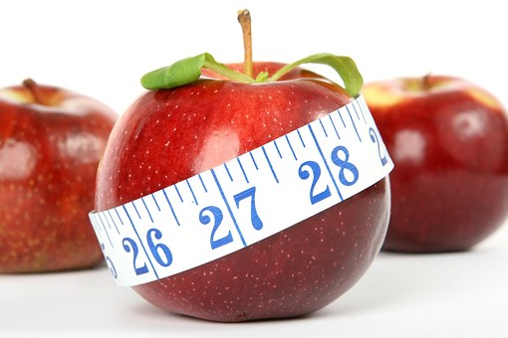
Three kinds of fat were identified in the human body. Two of them are normal and essential. The third is both inessential and abnormal. Only the inessential, abnormal fat creates obesity.
The first kind of normal fat – also known as visceral or structural fat – acts like upholstery or packing material to cushion our internal organs. It guards delicate structures such as the bladder, the spleen, the kidneys and the eyeballs by embedding them in soft elastic tissue. It also protects the coronary arteries, helps keep the skin firm and smooth and creates the vital cushion of firm fat under the heels of the feet without which we would be unable to walk without pain.
The second variety of normal fat is evenly distributed throughout the body. It provides an equally important reserve of energy so that, when there is a lack of food or a famine, we are able to call on this reserve to fuel our metabolism and keep us going.
Both these fats – structural and reserve – are important to the well-being of any man or woman. And even if your body chooses to store these essential fats to capacity, they will never make you obese. A healthy, well-fed body can function perfectly well for a limited time subsisting only on its normal fat reserves.
The kind of fat is inessential and abnormal fat you see in the build-up of the adipose deposits which distort our bodies. It creates beer bellies on men and spreading waistlines, thighs and bottoms on women. It is these inessential fat deposits that result in obesity. Theoretically, one would expect this kind of fat to function as a ‘reserve of fuel’ just as normal fat does. The problem is that in people with a tendency to gain weight, this non-essential fat gets ‘locked away’ beyond reach so that, even when your body needs energy, you are unable to access it.
When we go on slimming diets, or on fasts, instead of being able to tap into this kind of inessential fat, we often shed our normal reserves as well. This is one reason yo-yo dieters suffer such frustration. What’s worse, if we stay on one of these diets, it can result in a loss of essential structural fat, undermining our health.
Dr Simeons says: “When an obese patient tries to reduce by starving himself, he will first lose his normal fat reserves. When these are exhausted, he begins to burn up structural fat, and only as a last resort will the body yield its abnormal reserves, though by that time the patient usually feels so weak and hungry that the diet is abandoned. It is just for this reason that obese patients complain that when they diet they lose the wrong fat. They feel famished and tired and their face becomes drawn and haggard, but their belly, hips, thighs and upper arms show little improvement. The fat they have come to detest stays on and the fat they need to cover their bones gets less and less. Their skin wrinkles and they look old and miserable. And that is one of the most frustrating and depressing experiences a human being can have.
————————————————————————————————————————–
DR SIMEONS AND hCG
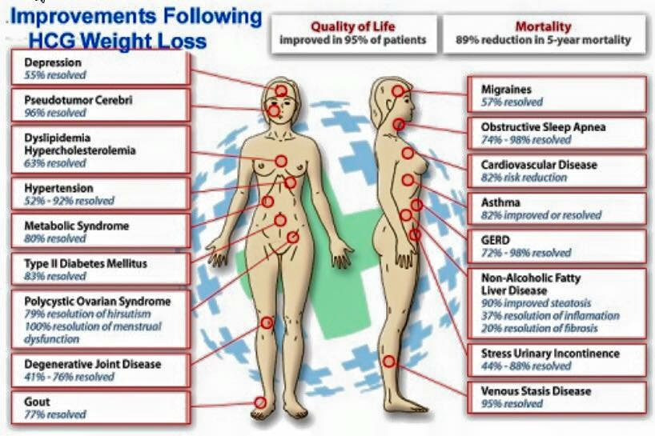
hCG is an acronym for human chorionic gonadotrophin – a protein-based hormone often called the pregnancy hormone. It starts being made in a woman’s body seven or eight days after conception. hCG is the largest and most complex glycoprotein present in the human body. It holds some 300 amino acids in its molecular structure.
The presence of hCG in the body strongly affects the diencephalon’s fat-banking.
Pregnancy seems to be the only normal human condition in which the diencephalic fat banking capacity is unlimited. It is only during pregnancy that fixed fat deposits can be transferred back into the normal current account and freely drawn upon to make up for any nutritional deficit. During pregnancy, every ounce of reserve fat is placed at the disposal of the growing foetus. There is considerable evidence to suggest that it is the hCG produced in large quantities in the placenta which brings about this diencephalic change.

