Intervene Herbal

Intervene Herbal is a nutritional Anti-Cancer supplement which kills bacteria and cleanses the body and blood of toxins. Intervene, regulates and rejuvenates you while helping the body to reach an optimum pH balance and boost the immune system.
It consists of pure organic essential oils that have powerful Antiseptic, Anti-Bacterial, Anti-Viral and Anti-Fungal activity that supports the body, detoxifies the blood without undesirable side effects.
Intervene has up to date achieved phenomenal success rates, not only towards the struggle against Cancer & Tumours, but has also shown to be a successful herbal Immune Booster and treatment that assists against:
Aids support, Arthritis, Cancer (All types), Candida, Chlamydia, Diabetes, Eczema, Emphysema, Glaucoma, Herpes treatment, Immune Booster, Parkinson’s, Prostate, Sores, Skin Acne, STD’s (All types), Stomach Ulcers, Tuberculosis, Tumours, Psoriasis, Scarring, Allergies, Back pain, Bladder infection, Blood infection, Blurred Eye Vision, Infections (general), Inflammation, Gout, Joint pain, Kidney infection, Neuralgic pain, Relieving swelling, Yeast infection, Septic Ulcers, Skin Blemishes, Skin infections, Skin rashes, Spider Bites, Urinary Infection.
It is important to note that Intervene Herbal is not a toxic chemical based medication but a well refined herbal supplement, constructed from the highest quality blend of botanical oil extracts produced with advanced Quantum Angstrom Technology (QAT)
Intervene offers 3 x primary benefits:
Index 1. Balancing the bodies PH levels through an alkaline diet…
Index 2. Detoxify the body & blood from toxicity…
Index 3. Intervene fights diseases head on with the help of its meticulously selected range of essential oil ingredients.
Index 4. Besides the extensive healing benefits thanks to it’s the essential oils ingredients, Intervene has one more secret behind its success; Quantum Angstrom Technology (QAT) that takes Herbal supplements right out of the normal format.

“No disease, including Cancer can exist in an alkaline environment.” From Nobel Prize winner. Dr Otto H Warburg

1. Balancing the bodies PH levels through an alkaline diet…
Intervene PH balance. By nature, most fresh plant based foods have a high pH (are alkaline), but manufactured processed foods, grains and animal proteins have a low pH (are acidic). It is important that daily dietary intake of food naturally balances body pH.
Disease and infection are able to proliferate when the body’s pH is low (too acidic). It is also when the intracellular pH becomes acidic that oncogenic genes are activated. This is often as a result of acid forming foods, high fat, mucus forming foods, and toxic food residues. Examples can be seen in cases of arthritis and rheumatic situations. There is extensive research showing that Cancer exists and flourishes in an acidic environment, and it deteriorates and dies in an alkaline environment. Making the body more alkaline is important in fighting many kinds of diseases. So, we focus on alkalizing the body……and alkaline body creates harmonious thinking too!
However this is easier said than done, our modern lifestyle and diet makes it very difficult indeed to maintain a healthy pH balance. Supplementing your diet with Intervene Herbal which has an alkalinity of 10.7 can help keep a healthy balance which in turn greatly assists the body’s defences and natural healing mechanisms.
2. Detoxify the body & blood from all types of toxins:
Intervene Herbal Blood Analysis
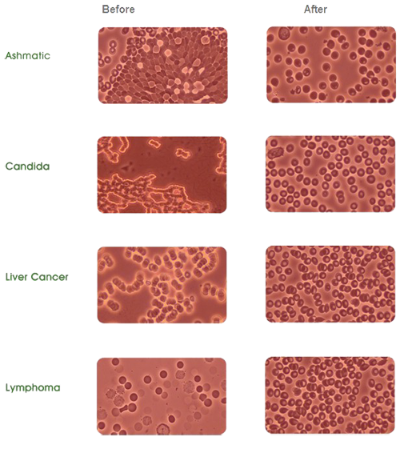

According to the latest and relevant research studies, we are living in an highly toxic age. Detox is one of the most vital actions requited to resist diseases causing toxicities like:
Endocrine-disrupting chemicals (EDCs),
Pesticides – Pesticides, insecticides, and herbicides are designed to destroy life.
“Soft” and Heavy Metals,
Fluoride – artificial fluoride chemicals in public water supply
Food Additives, Preservatives, and Growth Hormones – that include chemical preservatives – Sodium benzoate, monosodium glutamate (MSG), refined sugars, artificial sweeteners, synthetic food colorants, and other synthetic non-foods.
Radiation – EMF (Electromagnetic Frequency), EMR (Electromagnetic Radiation)
Pharmaceutical Drugs – Pharmaceuticals are among the worst toxic offenders in our modern world…
It is imperative to combat chemicals to achieve optimum health, from minor illnesses, infections and allergies, to major diseases such as Cancers, HIV and other Life threatening chronic disorders.
3. Intervene contains more than 25 meticulously selected essential oils,
Intervene essential oilseach with insignificant health benefits intended to fight a variety of diseases head on.
Frankincense & Myrrh Oil, Essential Oil of Oregano, Coconut Oil, Peppermint Oil, Clove Oil, Chrysanthemum Oil, Cedar Oil, Cinnamon Oil, Citronella Oil, Garlic Extract Oil, Geranium Oil, Neem Oil, Lemongrass Oil, Grape Seed Oil, Lavender Oil, Borage Oil (Starflower Oil), Evening Primrose Oil, Honey, Lemon-juice, ionic antioxidant water.
Frankencense
Frankencense that has Proven effective, against the deadliest forms of cancers; it actually kills cancer cells.
Anti Tumor activity of Frankincense and Myrrh
Frankincense Anti-microbial action
Frankincense and Geranium essential oil suppress tumor progression

Oregano
Oregano – AntiCancer Benefits towards – Colorectal, Leukemia, Breast & Brain Cancer.
Anti-proliferate activity of essential oils on human carcinoma cell lines
Anti-inflammatory and anti-cancer activity of Oregano in human skin diseases
Anti-fungal and anti-bacterial activity
Activation of apoptotic signaling pathways in cancer cells

Garlic
Allicin (found in Garlic) has repeatedly demonstrated powerful antioxidant, anti-tumor, and generalized anticancer properties!
Allicin-Induced Apoptosis and Human Ovarian Cancer Cells
Allicin in Gastric Cancer
Immunomodulation and Anti-Inflammatory of Garlic

Lemongrass
Lemongrass Oil – Unbelievable Anti-Cancer Effects
Anti-proliferative effect and phytochemical analysis
Activation of intrinsic apoptotic signaling pathway in cancer cells
Specific tissue response to carcinogenic mammary cancer cells

Myrrh Oil
Myrrh Oil – Proven to be an antioxidant, astringent, anti-tumoral, anti-inflammatory, anti-fungal, anti-parasitic, antiviral, and analgesic (pain relieving) benefits.
Apoptosis in Human Breast Cancer
Anti-proliferative effects in Human Prostrate Cancer
Myrrh is early stage Liver Cancer

Neem Oil
Neem Oil – A Modern Day Medical Miracle?
Shown to induce “apoptosis” or programmed cell death in different types of tumor cells in laboratory conditions. shown impressive anticancer potential towards – colon, stomach, pancreas, lung, liver, skin, oral, prostate, and breast cancers.
Neem in prostrate cancer tumor growth
Potential agent for cancer prevention and treatment
Neem in cervical cancer

Peppermint Oil
Peppermint Oil – Cytotoxic effects against lung carcinoma, leukemia, and gastric cancer cells
Useful in Helicobacter Pylori chronic gastritis
Regulates prostrate cancer cells
Liver Fibrosis

Chrysanthemum Oil
Anti-oxidative and anti-melanogenic activities
Anti-proliferative activity in human colon cancer
Great potential of antibacterial effect against Bacillus subtilis and Staphylococcus epidermidis

Cedar Wood Oil
Cedar Wood Oil: Cancer fighting phytochemicals
Anti-proliferative acitivity in myelogenous leukemia cells
Biological activity against Herpes Simplex 1
Phytochemical and pharmacological activity of Cedar Wood Oil

Geranium Oil
Effective in Fighting Infections
Antibacterial activity of geranium oil against Gram-negative bacteria
Effective for treatment of allergic diseases

